**EX.2-LED CHASER**

**Circuit Diagram:**

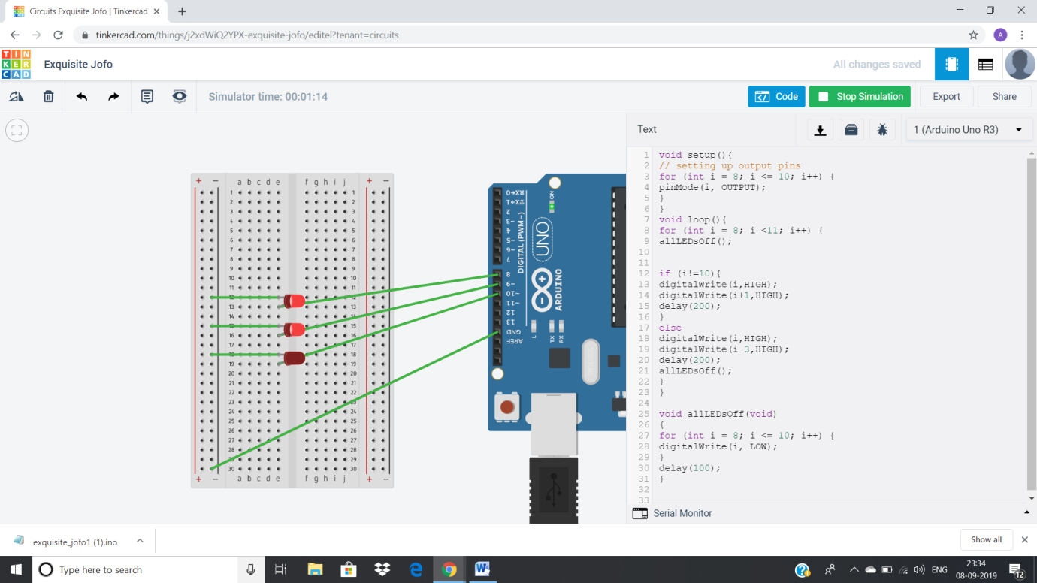

**Theory:**

**Concept Used:**

1)In this experiment I have used the concept of p-n junction diode.

2) To make a circuit on Bread Board.

3) Logic code for Arduino UNO, using Loop statement.

4)How and why resistance is used in a circuit.

**Learning and Observations:**

Learning:

1)I have learnt to use Arduino Board and how code works to make light flash.

2)Arduino board has Digital pins and Analog pins.

Digital pin provides Input as well as Output, but Analog pin provides only input.

3)The Arduino board has ~ sign in Digital pin side which is also known as Pulse Width Modulation(PWM).

These pins help’s in getting analog results with digital means.

4)How a circuit on breadboard is placed so that it can work properly.

5)Digital Pin provides 5V Power supply to the circuit.

**Observations:**

1)If we connect the ‘n’ terminal of the LED to other terminal except ground(GND), hence the circuit will be incomplete and we cannot get the desired output.

2)I connected the ‘p’ terminal of the p-n junction diodes to the Digital pins 9 in combination with the resistance, and ‘n’

4)If we connect the ‘p’ junction of LED to the 5V of analog the the light will not blink it will remain to glow.

**Problem and Troubleshooting:**

1)I have connected the ‘p’ terminal of the LED to analog side 5V terminal, but we cannot use that terminal because it can take input only it cannot provide output like digital terminals.

2)The LED was not glowing due to its loose connection. By reinserting it again I was able to fix this issue.

3)I have written the code for 7 number digital pin instead of 9.

Then I rechecked the code and corrected the error.